Welcome to the Chess wiki!!

TEAMS

Game name- Chess

Team member- Neil Dedhia, Alex Haider

OVERVIEW SCREENS AND FLOW

The history of chess can be traced back nearly 1500 years, although the earliest origins are uncertain. The earliest predecessor of the game probably originated in India, before the 6th century AD; a minority of historians believe the game originated in China. From India, the game spread to Persia. When the Arabs conquered Persia, chess was taken up by the Muslim world and subsequently spread to Southern Europe. In Europe, chess evolved into roughly its current form in the 15th century.

GAME SCREEN AND FLOW

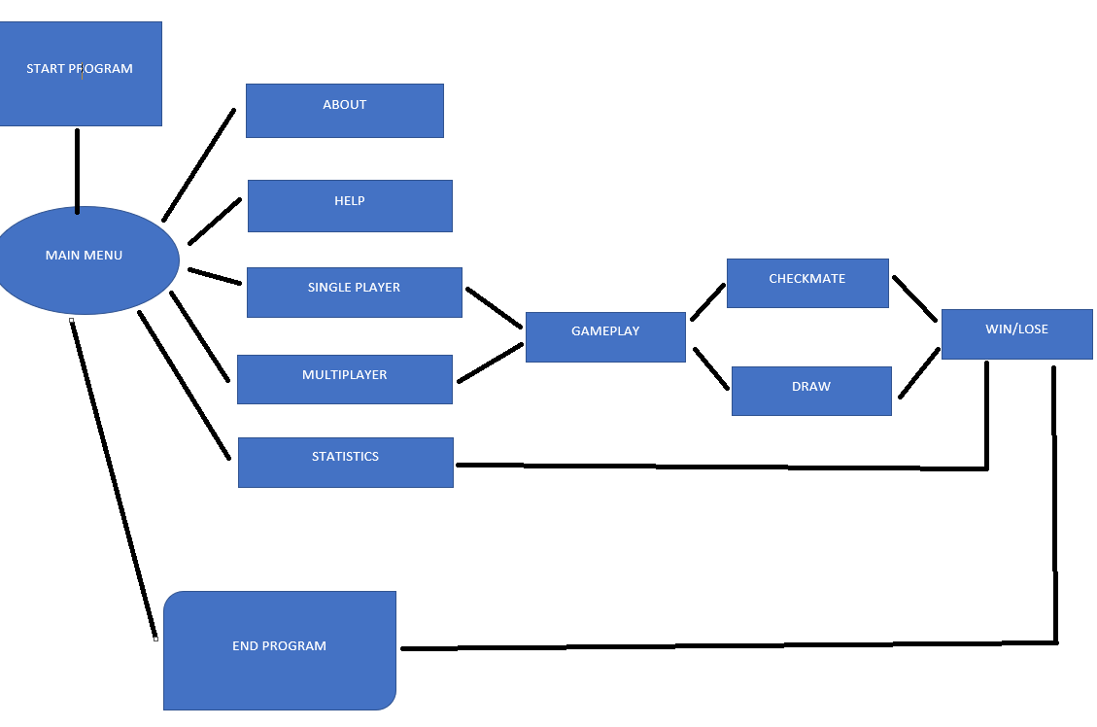

GAMEPLAY OF CHESS

1. Click either one player or two player

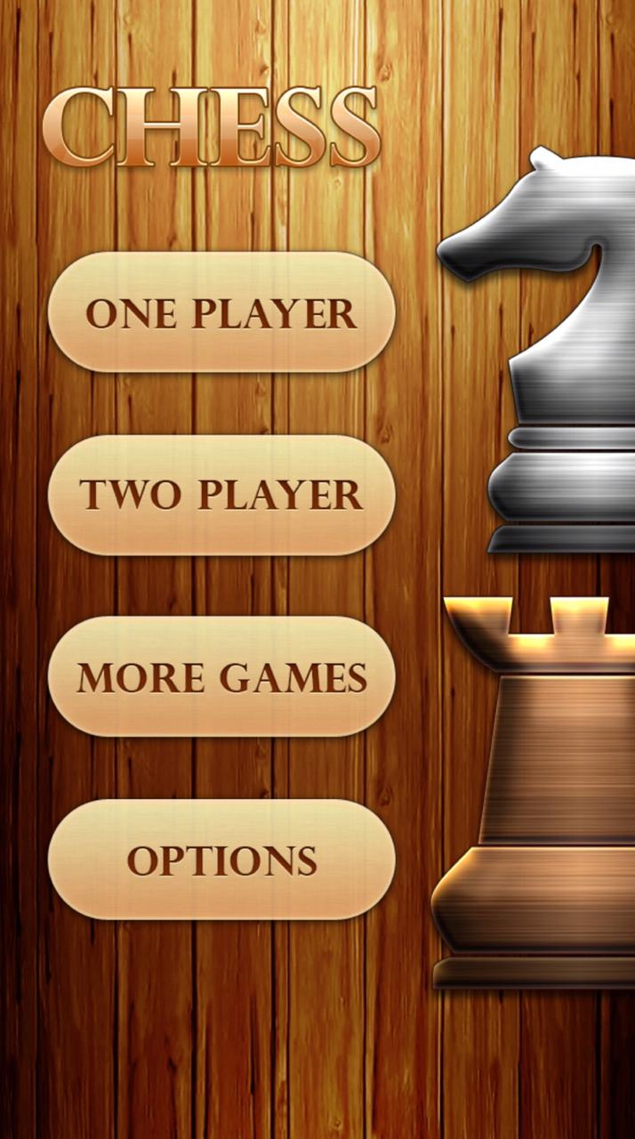

1. You will be assigned either black or white and you have to move pieces, every piece moves in a particular sequence.

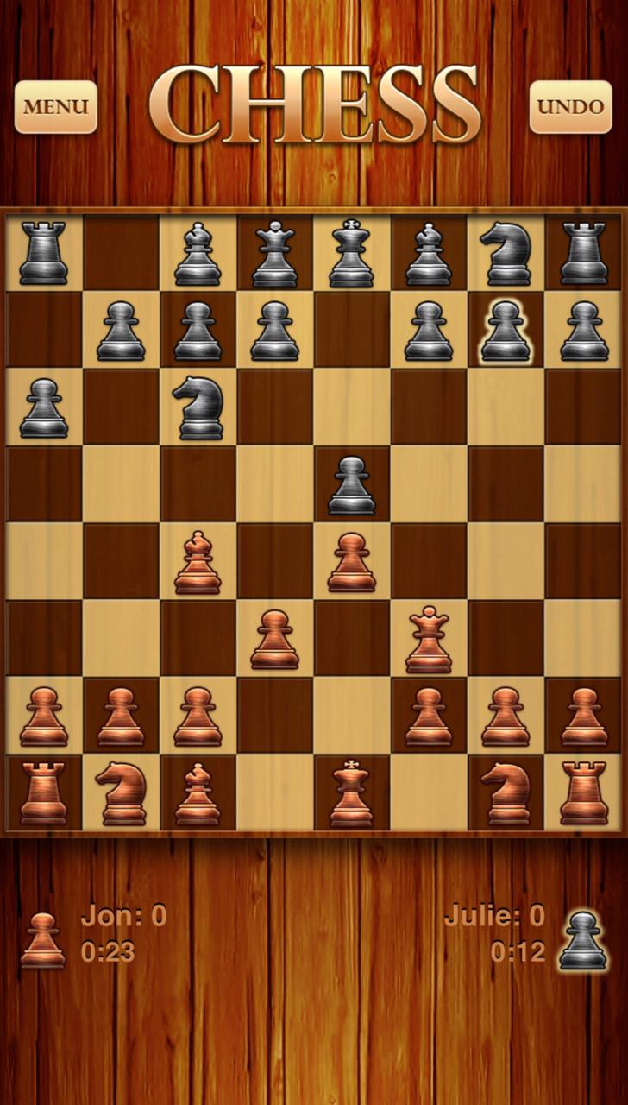

1. Result of the game.

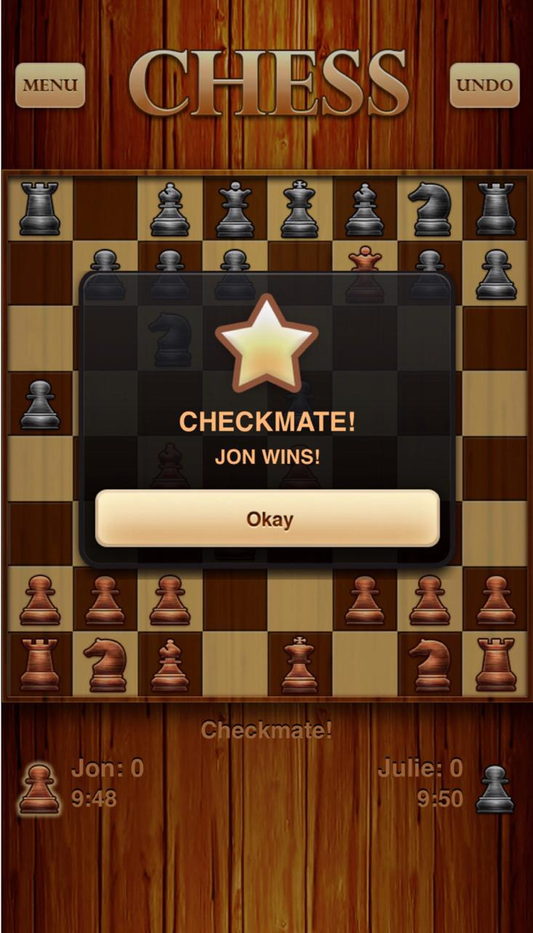

1. You can also select options where you’ll get various features and you can change it on your own convenience.

